**HANOI UNIVERSITY**

FACULTY OF INFORMATION TECHNOLOGY

------------------------------------

**HUMAN – COMPUTER INTERACTION FINAL REPORT**

**Teacher: Nguyễn Hữu Cầm**

**Student: Vũ Quang Anh**

**Đỗ Mạnh Hải**

**Bùi Quang Thành**

**Bùi Ngọc Trung**

**Nguyễn Duy Tùng**

**Class: 3C-16**

**Course: Human Computer Interaction**

**Date: June 10, 2019**

# **Abstract**

*Information and technology has played a very important part in our daily lives. This is the reason why in the course Human Computer Interaction, Spring 2019, Faculty of Information Technology, we have created our Technology News website to provide a full-fill and widen knowledge to help readers update and keep pace with today technology era. We believe that with the content and the design structure performed in the website, we can give you a new kind and new style of reading information technology news with a short presentation. Besides, we are students, we are not mature and experienced enough to produce a perfect webstie for reading, so we still have some issues in creating a website. This report, updated at 8:42, 10/06/2019, is created to point out these issues, which may help other students gain thier own experience to have the better webstie in the future.*

Contents

**Abstract** i

**1.Discussion of findings** 1

**1.1 Group 02** 1

**1.2 Group 03** 2

**1.3 Group 04** 4

**1.4 Group 05** 6

**2. Conclusion** 10

# **1.Discussion of findings**

## **1.1 Group 02**

We cannot click on any posts on Lastest Blog Post and category tags under each news title, bacause they do not have a link for these buttons.

When we click on the Web category, it should change the name into Lastest ‘Web’ Post, but unfortunately they do not. This can lead to reader’s confusion bacause they do not know the articles they are reading belong to which categories.

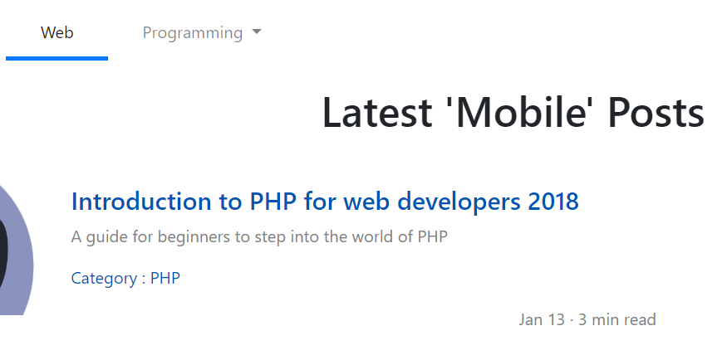

We identify that the AI category have two different colors when showing it in the front-end interface, which againsts the Consistency principle. This can also cause reader’s confusion.

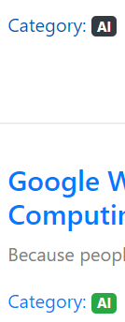

When we click on categories and random articles, they do not have links for that.

When we test the role management, they redirect us to 403 Forbidden Access, announcing that we do not have the authority to access that field. When we click on the ‘Go Back” button, which is supposed to redirect us to other pages, but it stops working and we cannot go to others element on this website.

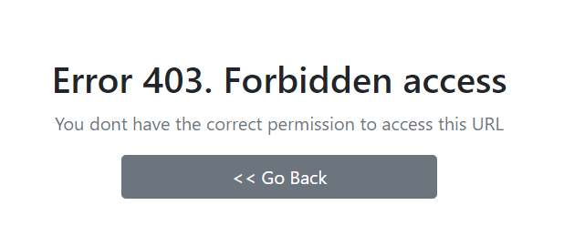

We also want to recommend that the group should do the following things

1. ‘Become a member’ button should be on the right ‘Log in’ button because we see a lot of blank space and nothing is full-filled.



1. Log in interface should have something in common with the whole website structure
2. We have read one big article that have three parts in total. We think it would be better if the recommendations should be in the end of article, followed by the current trends in featuring next articles in numbers of news website.

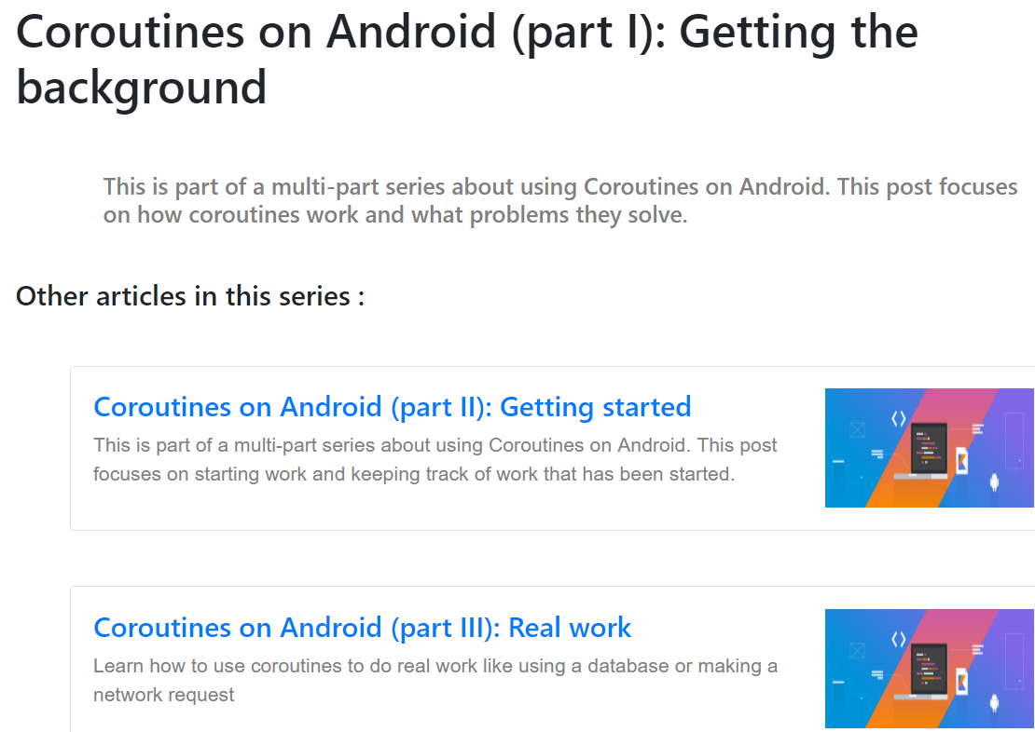

1. When clicking the logo of the website, it should redirect us to the homepage, which help the readers go back directly on the homepage without clicking too many times on the ‘Back” button.
   1. **Group 03**

They have a lot of dummy texts in both backend and frontend interface, it means that the website is not completed.

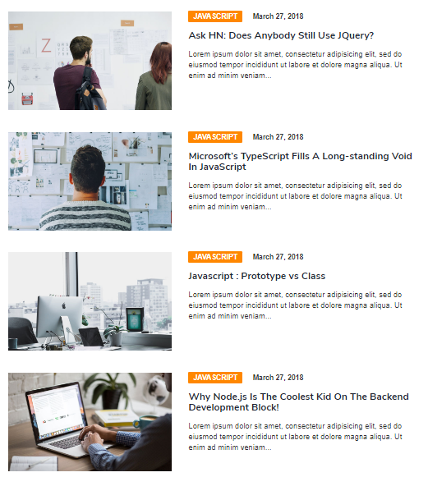 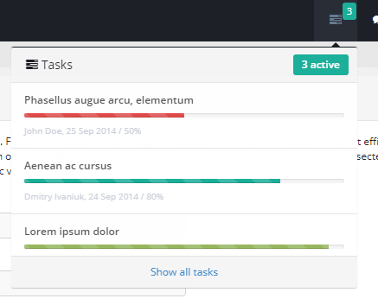

‘Login’ button is not included in the hompage, but it is shown in a detail of a article.





And these are some recommendations:

1. All the categories redirect to only one category ‘Javascript’, we think the group should have more pages equivalent to the number of categories they have.
2. There are something that are redundant in the footer.



To be more details, contact information is not correct. Moreover, there are two unwanted pixel lines in the top of the footer. The word ‘Catagories’ is not correct in spelling.

1. ‘Most Read’ and ‘Featured Post’ should be put in higher position because with these name, they deserve more focus rather than putting them under a lot of elements.
2. Why do we need these categories again? If it is for user’s convenicence without scrolling up, the group has already had categories part in the footer. We think that is unnecessary. Besides, the text is not justify – aligned. This lead to the unprofessional design and leave the bad impression to the users.

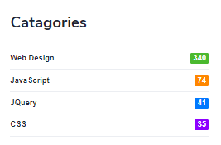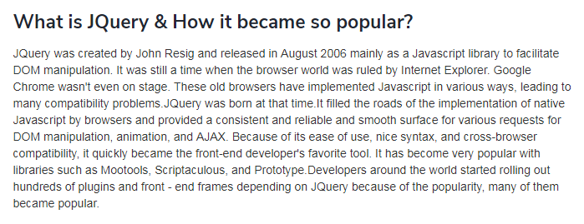

1. They have ‘Popular’ category, which means this should be hilighted according to many newspaper website, but we cannot see or recognize this is a standing out part. They should have something added like icons or effects to help this become remarkable, due to Familiarity principles.
2. In the Category table which have numbers of articles, the color of Jquery and CSS and corresponding number do not match, which go agaisnt the Consistency principle.

## **1.3 Group 04**

First of all, when we access to the “Home” page, we can see the Login/Register button on the top-right corner. But when click on “Programming/Software Engineering/Blockchain”, there is a “Create your blog” button. It means we can still post articles without logging in or registering. 

Moreover, in the “Create Post” page, people can still Publish/Save as draft articles even if there is no content ( a “Success” pop-up window will always appears whenever “ Publish/Save as draft” buttons is clicked). This may lead to problems such as strangers can access and post/save irrelevant information on their website.

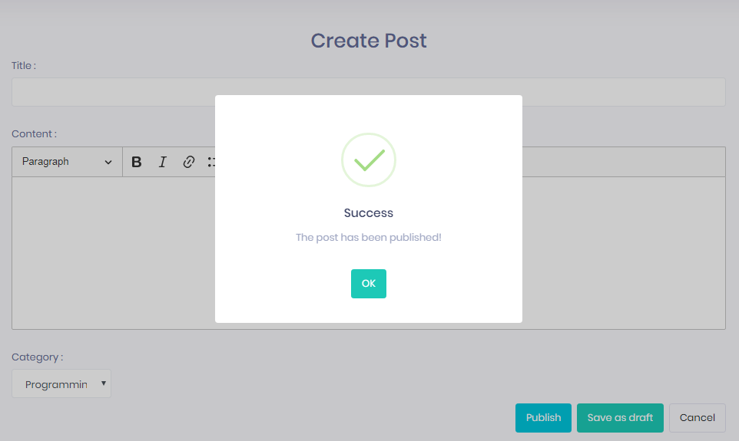

When reading an article, we notice that there is comments and author part. But we cannot click on those parts to see the details.

 

In every articles, we see that they are posted/written by “Admin”. We expected to see information about “Admin” but there is nothing happened when clicking on that button. The only thing that happened is the current page just loaded itself again.



Moving to the back-end pages, there are 4 fucntions Add role/ Add user/ Category /Add file that show the “successfully” pop-up even when we did not change or add anything.

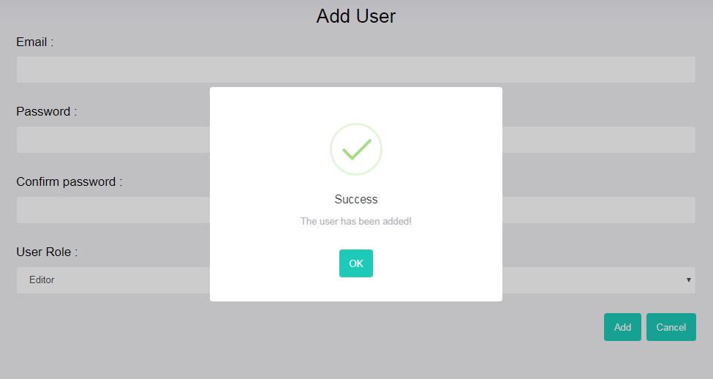

In addition, we cannot access to this area. It means the user function is useless.



Finally, we have some recommendations for this website:

1. In the “Hot news”, there is nothing to show up to the users that they are hot news. We noticed that the “Hot news” part is just as normal as the “Recent posts” part (because group 4 used a same font and a same color for that parts). We suggest using another color and an icon (optional) to make it more remarkable.



1. In the login/register page, you used too much white color. This should be changed to another kind of color in order to avoid boring.

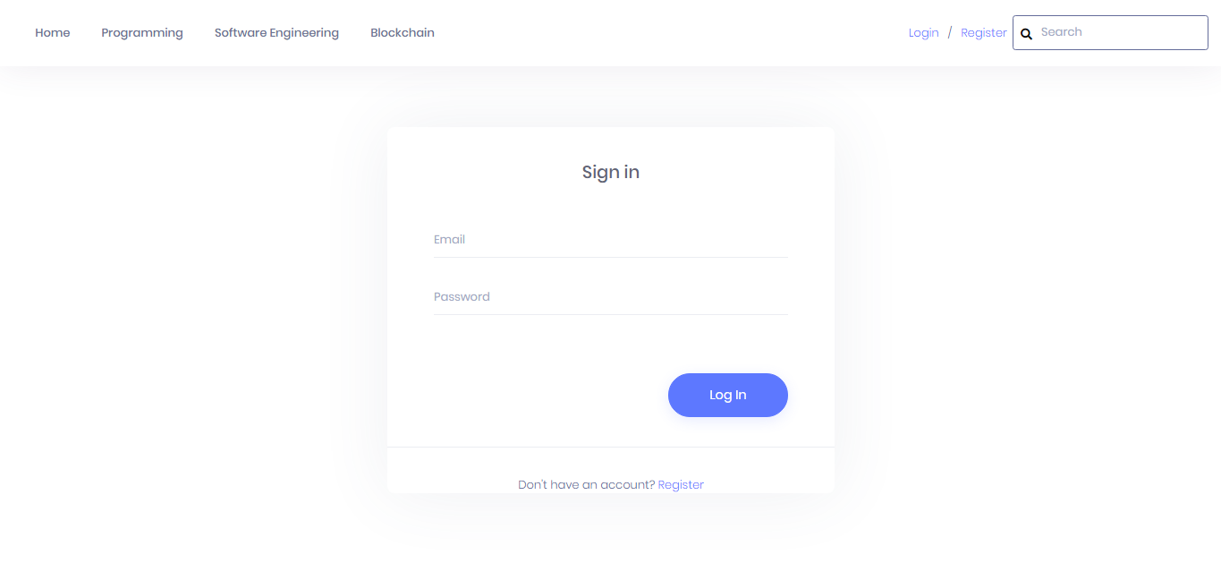

1. You should add a footer to your page. And this may include contact information about your website.



## **Group 05**

They included two languages in this website: English and Vietamese, which may cause user confusion because they violate the Consistency principle.

There is problem when clicking on the logo, home, new blog, file, and profile. The results are always the same: 404: Files Not Found

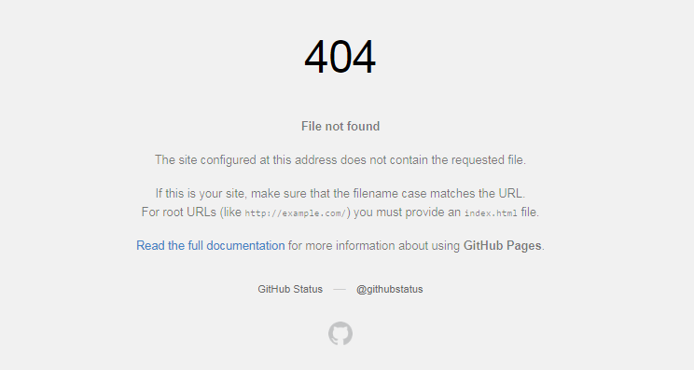

There is nothing happened when clicking on the “Read more” or “Read my bio” button

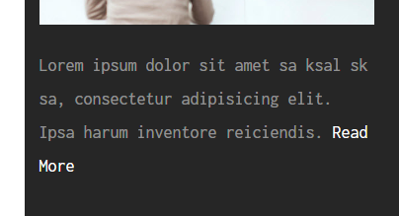

When accessing on the “Contact” page, there is no buttons or links to return home page. The other buttons show the errors. Moreover, when click “Send message” button, 405 error is showed.

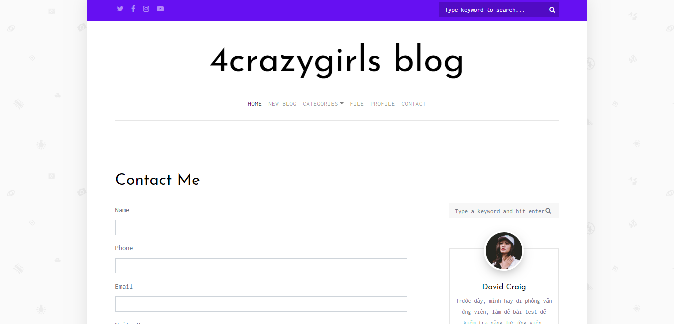

-



There are 2 search bars in one page, which is unnecessary and may confuse the users.

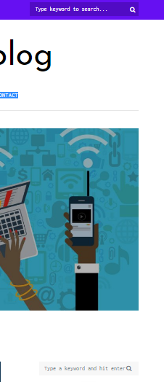

When looking at details, we noticed that the layout in this website is not comprehensive, and uncomfortable for users:

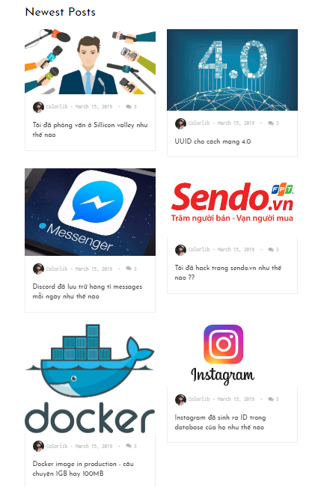

The content on this picture is not relevant to the subject of the website:

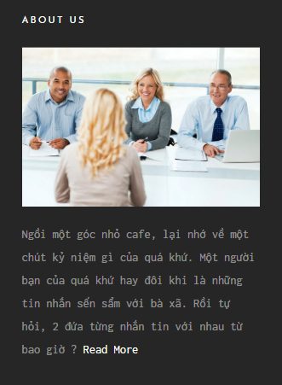

# **2. Conclusion**

We spent a lot of time to look at and investigate other group problems and try not to commit these issues, but due to member’s knowledge, mistakes are not unavoidable. We hope that after this project we can get a better knowledge and gain our own experience to produce a more advanced product in the future.